DATABASE EXPORT TO PDF/EXCEL/CSV/PRINT/COPY USING BUTTONS

TABLE.PHP:

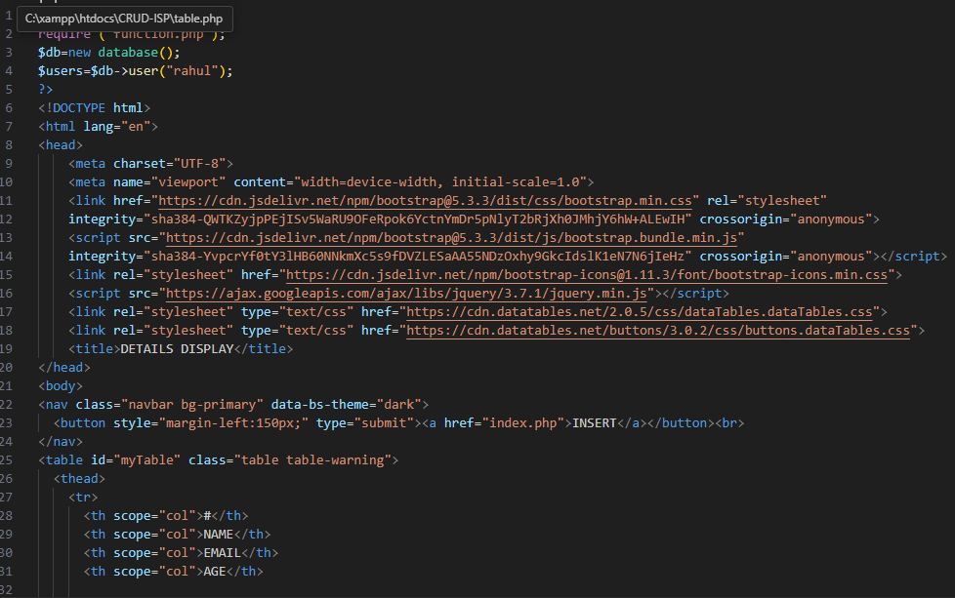

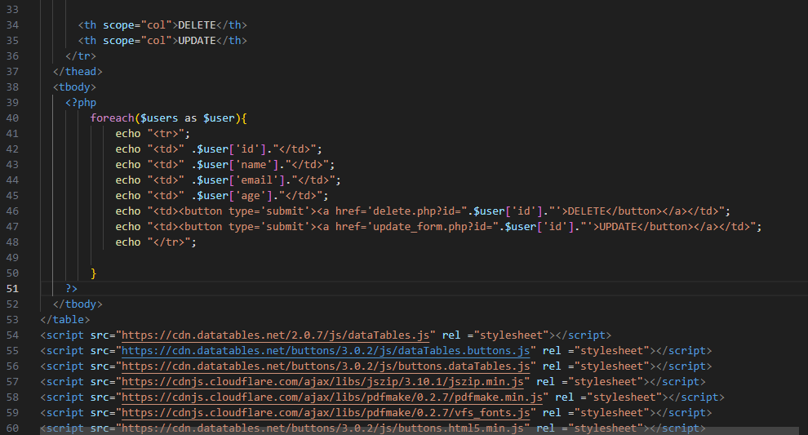

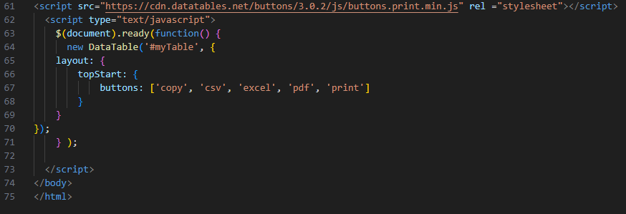

OUTPUT:

